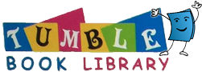

Dear Parents!

Our Library has a subscription to TumbleBookLibrary, and your family can access it from home! It’s unlimited, and it’s FREE for you to use from home!

TumbleBookLibrary is an online collection of e-books for children. They are a great way to encourage tech-savvy kids to enjoy reading!

There are over 250 animated, talking picture books! The site also features Spanish and French books, read-along chapter books, non-fiction books, and exciting games and puzzles!

We hope that you will get the chance to check out the collections with your child! Below is all the information you’ll need to login to the collection:

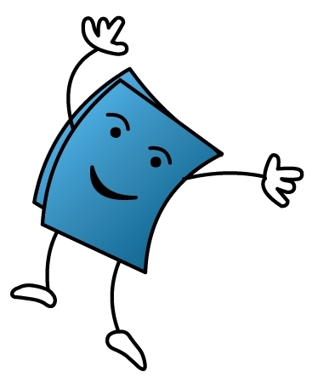
Visit our library’s website for access:

www.norfolkpubliclibrary.org

Click on the Books & More Tab. Scroll down and click on the TumbleBooks icon to begin the reading adventure!

You can use your computer, tablet, or mobile phone! All you need is an internet connection. There are no downloads: books are streamed right to your device at the click of a button.

1,477 Book Titles ~ Happy Tumbling, everyone!

