MADISON
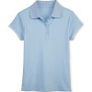
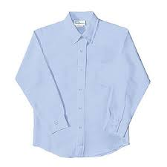
2016 -2017
Middle School (Grades 6-8)
DRESS CODE POLICY

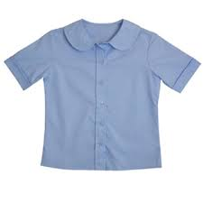
REQUIRED

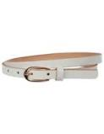
Shirt: Plain, short or long sleeved light blue with a collar. (No writing or designs)
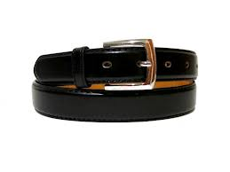
The shirt must remain tucked inside of the pants throughout the school day.
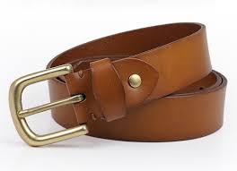

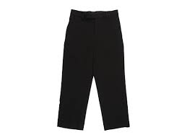
Belt: Plain black, plain brown or plain white (No designs or metal decorations) with a
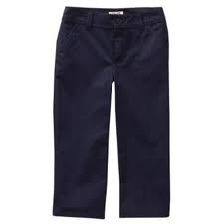
maximum 2 inch buckle. A belt is required to be worn on all pants with belt loops.

Pants: Long, solid black or navy blue. Pants must not sag below the waist.
(No jeans or denim, sweat pants, stretch pants, leggings, capris, pants with
large front/side pockets, or shorts)

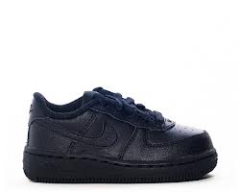
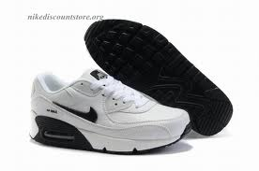
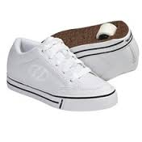
Shoes: All black, all white, or black and white (No other colors) with a flat closed toe and flat closed heel.
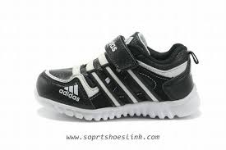
Boots are not allowed.

Shoe Laces: Plain black or plain white.

Socks: No inappropriate pictures or designs (No drugs, alcohol, weapons, gang symbols, etc.)

Optional

Optional Undershirt (T-Shirt or thermal underwear): Plain white or plain black (No writing or designs)

Optional Sweater: Plain white or plain black (No markings or hood). Button or full zip up the front only-
to be worn on top of the required school shirt.

Optional Jewelry & Hair Bands: Only small gold or silver tone stud earrings and a watch (gold-tone,
silver-tone, black, or white) are allowed. Hair bands must be plain black or plain white; no other colors.

Students are expected to dress appropriately for a K-12 educational environment. Any clothing that
interferes with or disrupts the educational environment is unacceptable. Clothing with language or
images that are vulgar, discriminatory, or obscene, or clothing that promotes illegal or violent conduct,
such as the unlawful use of weapons, drugs, alcohol, tobacco, or drug paraphernalia or clothing that
contains threats such as gang symbols is prohibited.
Clothing should fit, be neat and clean, and conform to standards of safety, good taste and decency.
Clothing that exposes cleavage, private parts, the midriff, or undergarments, or that is otherwise sexually
provocative, is prohibited. Examples of prohibited clothing include, but are not limited to: sagging or
low-cut pants, low-cut necklines that show cleavage, tube tops, halter tops, backless blouses or blouses
with only ties in the back, clothing constructed of see-through materials and head coverings unless
required for religious or medical purposes.
Additionally, disciplinary action will be taken against any student taking part in gang-related activities
that are disruptive to the school environment, which include the display of any apparel, jewelry,
accessory, tattoo, or manner of grooming that, by virtue of its color, arrangement, trademark, or any
other attribute, denotes membership in a gang that advocates illegal or disruptive behavior.

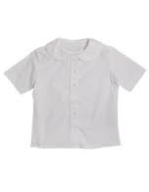
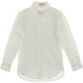
MADISON
2016 – 2017
High School (Grades 9–12)
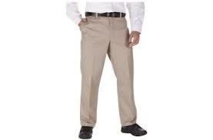
DRESS CODE POLICY
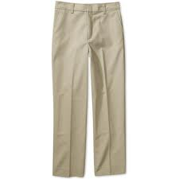
REQUIRED

Shirt: Plain, short or long sleeved white with a collar. (No writing or designs)
The shirt must remain tucked inside of the pants throughout the school day.
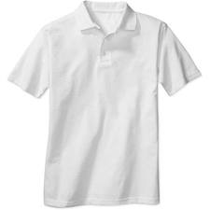
Belt: Plain black, plain brown or plain white (No designs or metal decorations) with a
maximum 2 inch buckle. A belt is required to be worn on all pants with belt loops.

Pants: Long, solid khaki/tan. Pants must not sag below the waist.
(No jeans or denim, sweat pants, stretch pants, leggings, capris, pants with
large front/side pockets, or shorts)

Shoes: All black, all white, or black and white (No other colors) with a flat closed toe and flat closed heel.
Boots are not allowed.

Shoe Laces: Plain black or plain white.

Socks: No inappropriate pictures or designs (No drugs, alcohol, weapons, gang symbols, etc.)

Optional

Optional Undershirt (T-Shirt or thermal underwear): Plain white or plain black (No writing or designs)

Optional Sweater: Plain white or plain black (No markings or hood). Button or full zip up the front only-
to be worn on top of the required school shirt.

Optional Jewelry & Hair Bands: Only small gold or silver tone stud earrings and a watch (gold-tone,
silver-tone, black, or white) are allowed. Hair bands must be plain black or plain white; no other colors.

Students are expected to dress appropriately for a K-12 educational environment. Any clothing that
interferes with or disrupts the educational environment is unacceptable. Clothing with language or
images that are vulgar, discriminatory, or obscene, or clothing that promotes illegal or violent conduct,
such as the unlawful use of weapons, drugs, alcohol, tobacco, or drug paraphernalia or clothing that
contains threats such as gang symbols is prohibited.
Clothing should fit, be neat and clean, and conform to standards of safety, good taste and decency.
Clothing that exposes cleavage, private parts, the midriff, or undergarments, or that is otherwise sexually
provocative, is prohibited. Examples of prohibited clothing include, but are not limited to: sagging or
low-cut pants, low-cut necklines that show cleavage, tube tops, halter tops, backless blouses or blouses
with only ties in the back, clothing constructed of see-through materials and head coverings unless
required for religious or medical purposes.
Additionally, disciplinary action will be taken against any student taking part in gang-related activities
that are disruptive to the school environment, which include the display of any apparel, jewelry,
accessory, tattoo, or manner of grooming that, by virtue of its color, arrangement, trademark, or any
other attribute, denotes membership in a gang that advocates illegal or disruptive behavior.

MADISON
2016 – 2017
ISAEP Program (GED Preparation)
DRESS CODE POLICY

REQUIRED

Shirt: Plain, short or long sleeved white with a collar. (No writing or designs)
The shirt must remain tucked inside of the pants throughout the school day.
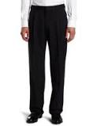
Belt: Plain black, plain brown or plain white (No designs or metal decorations) with a
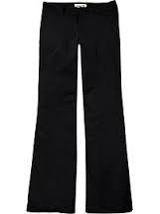
maximum 2 inch buckle. A belt is required to be worn on all pants with belt loops.

Pants: Long, solid black. Pants must not sag below the waist.
(No jeans or denim, sweat pants, stretch pants, leggings, capris, pants with
large front/side pockets, or shorts)

Shoes: All black, all white, or black and white (No other colors) with a flat closed toe and flat closed heel.
Boots are not allowed.

Shoe Laces: Plain black or plain white.

Socks: No inappropriate pictures or designs (No drugs, alcohol, weapons, gang symbols, etc.)

Optional

Optional Undershirt (T-Shirt or thermal underwear): Plain white or plain black (No writing or designs)

Optional Sweater: Plain white or plain black (No markings or hood). Button or full zip up the front only-
to be worn on top of the required school shirt.

Optional Jewelry & Hair Bands: Only small gold or silver tone stud earrings and a watch (gold-tone,
silver-tone, black, or white) are allowed. Hair bands must be plain black or plain white; no other colors.

Students are expected to dress appropriately for a K-12 educational environment. Any clothing that
interferes with or disrupts the educational environment is unacceptable. Clothing with language or
images that are vulgar, discriminatory, or obscene, or clothing that promotes illegal or violent conduct,
such as the unlawful use of weapons, drugs, alcohol, tobacco, or drug paraphernalia or clothing that
contains threats such as gang symbols is prohibited.
Clothing should fit, be neat and clean, and conform to standards of safety, good taste and decency.
Clothing that exposes cleavage, private parts, the midriff, or undergarments, or that is otherwise sexually
provocative, is prohibited. Examples of prohibited clothing include, but are not limited to: sagging or
low-cut pants, low-cut necklines that show cleavage, tube tops, halter tops, backless blouses or blouses
with only ties in the back, clothing constructed of see-through materials and head coverings unless
required for religious or medical purposes.
Additionally, disciplinary action will be taken against any student taking part in gang-related activities
that are disruptive to the school environment, which include the display of any apparel, jewelry,
accessory, tattoo, or manner of grooming that, by virtue of its color, arrangement, trademark, or any
other attribute, denotes membership in a gang that advocates illegal or disruptive behavior.

